

**MANAV RACHNA UNIVERSITY, FARIDABAD**

**Department of Computer Science and Technology**

**Course: B.Tech(CST) Semester:IV Subject: Programming for Problem Solving using Python(CSW208B) Session: 2020-21**

***Lab 4-5:*** *Operation on Tuples and List: hands-on practice*

***Learning Outcome*:** *Student will be able to implement Tuple and List:*

***Blooms Taxonomy Level****: BT1, BT2,BT3*

**Tuple**

1. Write a Python program to create a tuple.

Kajiman lawati

1141 cse 4c

Ans=coordinates=[3 ,5,4 ,5]

1. Write a Python program to create a tuple with different data types.

Ans=coordinates=[3 ,5,"kajiman" ,"lawati"]

1. Write a Python program to create a tuple with numbers and print one item.

Ans=coordinates=[3 ,5,4 ,5]  
print(coordinates[3])

1. Write a Python program to unpack a tuple in several variables.

Ans=coordinates=[3 ,5,"kajiman" ,"lawati"]  
print(coordinates[0])  
print(coordinates[1])  
print(coordinates[2])  
print(coordinates[3])

1. Write a Python program to add an item in a tuple.

ans=coordinates=[3 ,5,"kajiman" ,"lawati"]

coordinates.insert(2,"cse")  
print(coordinates)

**6.** Write a Python program to convert a tuple to a string.

coordinates=["kajiman" ,"lawati"]  
print(''.join(coordinates))

1. Write a Python program to get the 4th element and 4th element from last of a tuple

Ans=tuplex = ("w", 3, "r", "e", "s", "o", "u", "r", "c", "e")  
print(tuplex)  
item = tuplex[3]  
print(item)  
item1 = tuplex[-4]  
print(item1)

1. Write a Python program to create the colon of a tuple.

Ans=from copy import deepcopy  
#create a tuple  
tuplex = ("HELLO", 5, [], True)  
print(tuplex)  
#make a copy of a tuple using deepcopy() function  
tuplex_colon = deepcopy(tuplex)

tuplex_colon[2].append(50)  
print(tuplex_colon)  
print(tuplex)

**9.** Write a Python program to find the repeated items of a tuple.

Ans=coordinates=[3 ,5,"kajiman" ,"lawati","don","kajiman"]

kaji=coordinates.count("kajiman")  
print(kaji)

1. Write a Python program to check whether an element exists within a tuple.

Ans=coordinates=[3 ,5,"kajiman" ,"lawati","don","kajiman"]  
print(coordinates.index(3))

1. Write a Python program to convert a list to a tuple.

Ans=def convert(list):  
 return tuple(list)

list = [1, 2, 3, 4]  
print(convert(list))

1. Write a Python program to remove an item from a tuple.

Ans=  #create a tuple  
tuplex = "w", 3, "r", "s", "o", "u", "r", "c", "e"  
print(tuplex)  
#tuples are immutable, so you can not remove elements

#using merge of tuples with the + operator you can remove an item and it will create a new tuple  
tuplex = tuplex[:2] + tuplex[3:]  
print(tuplex)  
#converting the tuple to list  
listx = list(tuplex)  
#use different ways to remove an item of the list  
listx.remove("c")  
#converting the tuple to list  
tuplex = tuple(listx)  
print(tuplex)

**13.** Write a Python program to slice a tuple

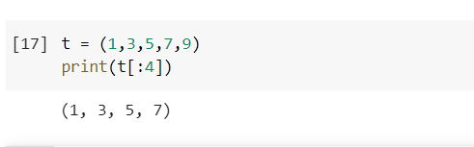

**14.** Write a Python program to find the index of an item of a tuple.

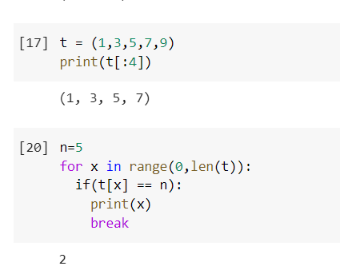

**15.** Write a Python program to find the length of a tuple.

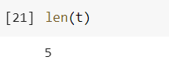

16. Write a Python program to reverse a tuple.

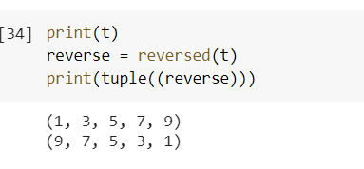

List

**1.** Write a Python program to sum all the items in a list.

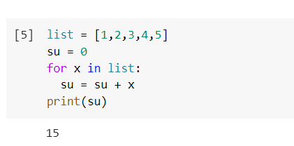

**2.** Write a Python program to multiplies all the items in a list. 

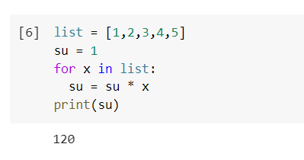

**3.** Write a Python program to get the largest number from a list

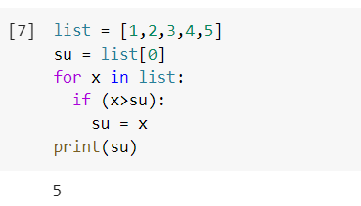

**4.** Write a Python program to get the smallest number from a list.

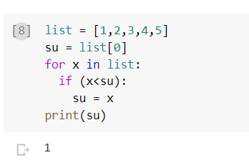

**5.** Write a Python program to count the number of strings where the string length is 2 or more and the first and last character are same from a given list of strings   
Sample List : ['abc', 'xyz', 'aba', '1221']  
Expected Result : 2

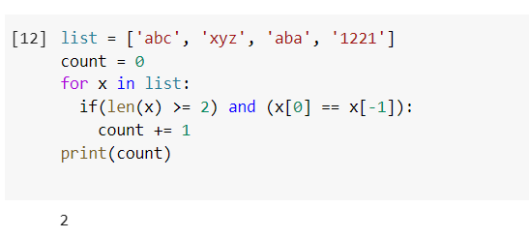

**6.** Write a Python program to get a list, sorted in increasing order by the last element in each tuple from a given list of non-empty tuples.    
Sample List : [(2, 5), (1, 2), (4, 4), (2, 3), (2, 1)]

Expected Result : [(2, 1), (1, 2), (2, 3), (4, 4), (2, 5)]

**7.**Write a Python program to remove duplicates from a list.

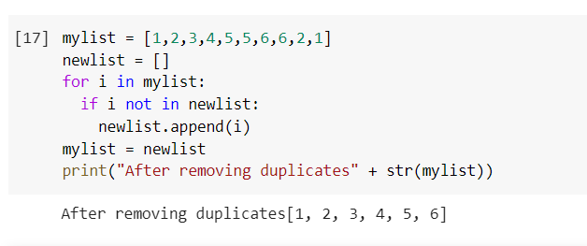

**8.**Write a Python program to check a list is empty or not.

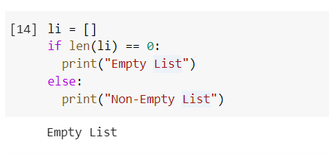

**9.**Write a Python program to clone or copy a list.

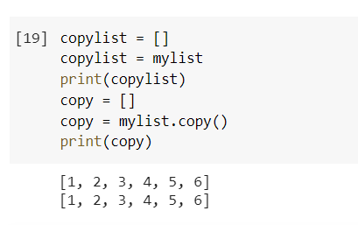

**10.**Write a Python program to find the list of words that are longer than n from a given list of words.

**11.**Write a Python function that takes two lists and returns True if they have at least one common member.

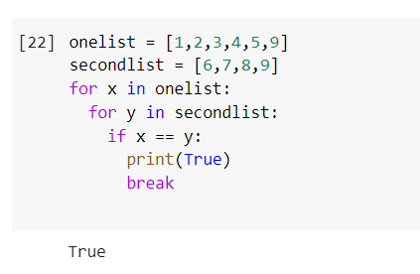

**12.**Write a Python program to print a specified list after removing the 0th, 4th and 5th elements.    
Sample List : ['Red', 'Green', 'White', 'Black', 'Pink', 'Yellow']  
Expected Output : ['Green', 'White', 'Black']  
